**ECE 411 Product Design Specification**

**Team 14**

Nathan Truong, Eisa Alsharifi, Aziz Alshaanban, Fernando Custodio Calderon

Create a PDS for your practicum project, and upload it to your collaboration site. Sections should include:

* **Short Descriptive Name**

Electric Vehicle Sound Muffler

* **Executive Summary with Concept of Operations (2 pts)**

Our product the Electric vehicle sound muffler is a device that makes electric vehicles sound like traditional gas powered cars. It’s designed for people with electric vehicles who want to have their vehicles sound like a traditional vehicle that has a powerful, loud engine.

Our product uses an accelerometer and a throttle position sensor to track the car's speed and movement. These sensors send information to the Arduino Uno. The sounds are played through speakers, allowing an engine revving noise to be heard that changes as the vehicle speeds up or slows down. Once installed, the muffler works automatically, generating powerful engine sounds as the vehicle drives. It gives drivers a more engaging experience, making it less boring when going on a ride. You won’t be bored with the sound of silence while driving anymore.

* **Brief “Market” Analysis (2 pts)**

Our intended customers are anyone who has an electric vehicle and would like to have a better driving experience by adding the sound of a traditional car. Also our product would be great for just any car enthusiast.

Our main competition would be competitors who make third party noise systems and other types of sound generators made for electric vehicles. Our product stands out because it will use real-time sound based on how a vehicle is performing, thus making it feel like a more authentic experience.

Our product will be sold for somewhere between $200 - 300. We chose this price because it will cover the price of our components and remain affordable enough for anyone looking to enhance their driving experience in their electric vehicle.

* **Requirements:** 
  + The device MUST be compact and lightweight, SHOULD be easy to install. A complete beginner should be able to learn how to install this device in 10-15 minutes of reading the manual.
  + The device MUST have low power consumption to avoid affecting the vehicle performance, SHOULD use energy-efficient components and sound amplification circuits. It MAY use a solar charging system or a rechargeable battery.
  + The Sound frequency MUST be clear and realistic to match the accelerometer even at higher volumes. The product MUST be fully automated and reflects the real-time throttle data as well as the speed of the vehicle using CAN bus
  + Safety is a MUST, It will have water resistance incase of rain and proper insulation incase of heat. To prevent any potential fire hazards.
  + The total cost of the product should fall within the $200-300 price range.
  + The device SHOULD be compatible with e-scooters, e-bikes, and small electric cars ranging from 12V to 48V.
  + The product MUST be durable and robust enough to withstand vehicle vibration and It SHOULD maintain 3 years EOL (End of Life).
* **System Architecture (4 pts)**
  + This is your *proposed* design, from a high level.
  + Create a Level 0 and a Level 1 block diagram: one block per major section (e.g., processor, input, output, power supply, etc) with interconnections in between them. Label all interconnections with what kind of interconnection they are. I.e., Is it an I2C connection? Or PWM? Or Analog? Or a simple digital bit? Label all blocks. If it makes sense to put the part number in the block, go ahead.

Level 0 block diagram

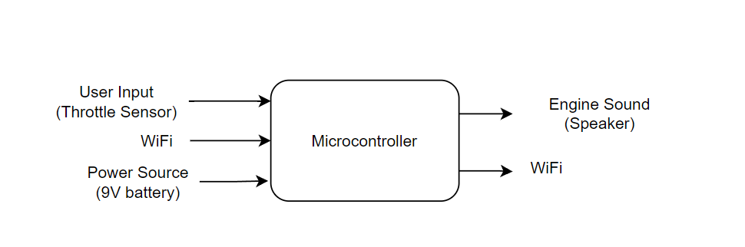

Level 1 block diagram

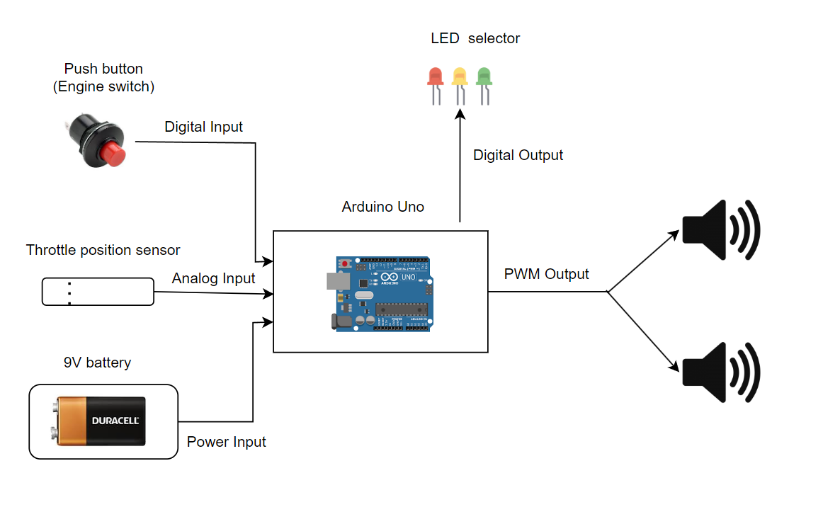

* **Design Specification (4 pts)**
  + OK, *now* put in your first swing at the technical details on the design.
  + A list of bullet points is fine here: What is the sensor? Processor? Actuator? Power? Mechanical design? Firmware? Arduino or no? Development environment?
* **Sensors:**
  + **Throttle Position Sensor:** Simulates throttle input to determine the intensity of engine sound variations based on the vehicle’s simulated speed.
* **Processor:**
  + **Arduino Uno:** Built into the custom PCB to process sensor data and produce required audio signals. The design contains all of the Arduino Uno's supporting components on the PCB.
* **Actuator:**
  + **2 Speakers in Exhaust:** The speakers will be installed inside an exhaust structure to replicate the acoustic environment of a traditional car exhaust. This setup will mimic sound propagation and improve the realistic feel of the created engine sounds.
  + **Audio Amplifier:** The PCB will feature an amplifier that boosts audio signals before they are sent to the speakers.
* **Power:** 
  + **9V Battery:** The entire system will be powered by a 9V battery, with onboard voltage regulation circuits to step down the voltage appropriately for the microcontroller, Wi-Fi module, and other components.
* **Mechanical Design:** 
  + The custom-designed PCB will be safely contained in the exterior like a car exhaust. The throttle position sensor will be programmed to collect precise data to power the sound generating algorithm.
* **Firmware:**
  + The firmware on the Arduino Uno will process sensor data and make engine noises in response to simulated vehicle settings. The code will incorporate algorithms for making real-time sound modifications in response to changes in throttle input.
  + The Wi-Fi module allows for remote monitoring or control, providing users to configure or alter sound parameters via a remote control.
* **Development Environment:**
  + **Arduino IDE:** The firmware will be developed using the Arduino IDE, with an ICSP programmer used for uploading the code to the integrated Arduino Uno.
  + **Signal Processing Libraries**: Custom libraries will be used to process data from sensors, generate sounds, and communicate over Wi-Fi.

**Important Notes:**

* Format nicely, include all the standard things: Title, team #, names, page #s, sections, etc. (2 pts)
* Spell check it, and *write it in a direct, simple, active voice. (2 pts)*
* Pictures are good, when useful. Gratuitous pictures are not good.
* This should only be 2-3 pages.

*Do you have questions or comments on this homework assignment?* [*Please comment on them*](https://docs.google.com/document/d/1nJ0h3Kt8DzWNtDH8clwRYJSPpL84hkGHvUycuXD6klI/edit?usp=sharing)*!!*